**Sick Leave / Permission Letter**

Date : Friday , 4 Febuary 2022

To : Sir Andi Wote

From : Erniwaty

Through this letter, I would like to inform you that my child,

Name : Angel

Student ID : 03013200001

Class : 20H2

Subject / Course : Bahasa Indonesia

is not able to attend the class session/s on _____ Saturday , March 19 2022 _________ _______________ (date/s of sick / permission). The reason of being absent is

__ Family Outing__________________________________________________________________________________________________

____________________________________________________________________________________________________

Regards,

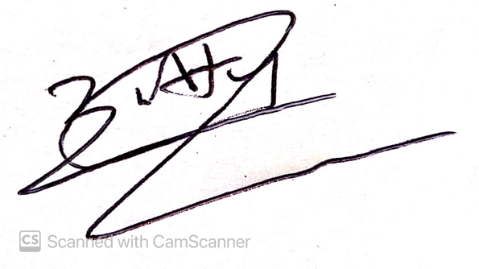

(Erniwaty)

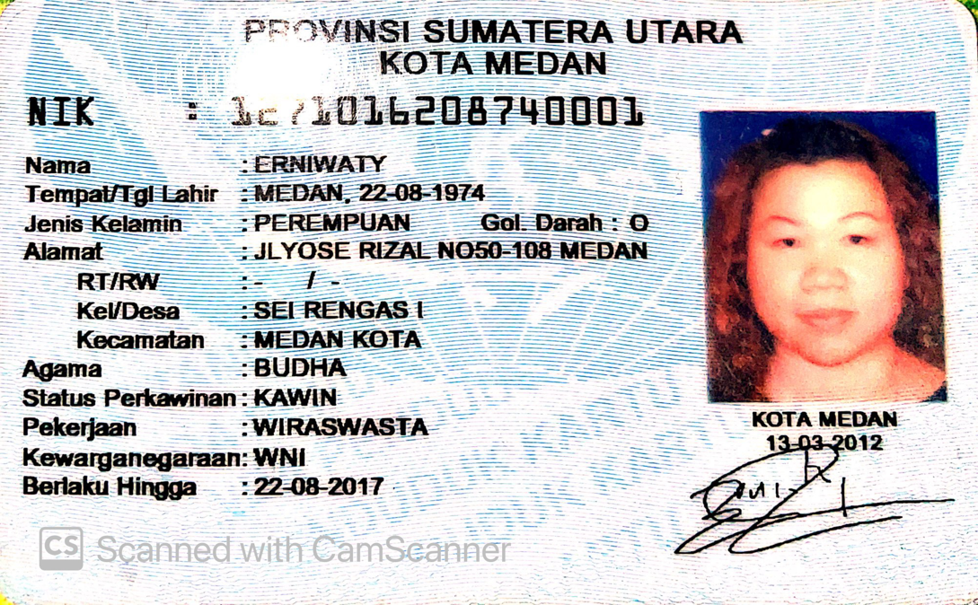

* Students may be exempted from being absent due to sickness by attaching a medical certificate.

* Any permission for being absent is allowed a maximum of 1 (one) time by attaching a photocopy of the parent’s ID card.

* This letter and the required attachment(s) must be submitted in 2 copies, 1 copy submitted to the Lecturer in class and 1 copy submitted to Student Services Center.